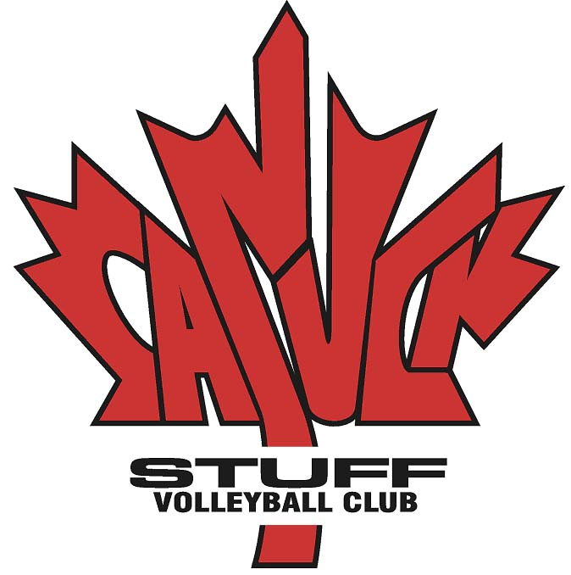

Canuck Developmental Philosophy

We proudly display over 70 Provincial and National Championship banners earned by Canuck teams, but our primary focus has never been about winning, but rather the preparation and development of these young people as athletes, volleyball players and team mates.
We believe that learning the “process” of becoming really good at something you are passionate about is a skill that serves people throughout their lives and understanding the relationship between “process” and “outcome” is a big part of that learning. Realizing that the 85% of the season we spend practicing and training is more important and more valuable than the 15% we spend playing the game.
Over the past number of years Canuck has created a philosophy and a successful process for developing young athletes that is very much in line with the Long Term Athlete Development (LTAD) plan which was created by Sport Canada and refined into a Volleyball specific model by Volleyball Canada. At the younger age groups (U14 & U15) we focus on teaching and refining fundamental skills and introducing transitional aspects of the game. Players should learn all the skills and learn about all the positions. As players evolve through the middle and older age groups (U16 to U18) (the “Train to Train” & “Learn to Compete” phases of LTAD) the emphasis begins to shift towards a more specific positional training and tactical components creating a team chemistry and ultimately preparing athletes for College or University and the “Train to Compete” and “Learn to Win” phases. Throughout this entire process we strive to build character and help these young people develop a set of life skills that will serve them throughout their lives.
Over the years our coaches, board and technical committee have had endless discussions about being a “competitively” focused club or a “developmental” club. We have always been recognized as both, and have strived to manage the balance between the two sometimes conflicting philosophies. With the creation of the Jr. Canuck Program we now have two streams, “Canuck Stuff” (developing our most competitive teams) and the “Jr. Canuck Program” (running our younger, more developmental teams).
Both programs have their teams compete in Premier Tournaments, Provincials and Nationals run within the Volleyball Alberta Club system. The main difference for the “Jr. Canucks” is the way the program is delivered. The athletes practice in a larger group that is run by a very experienced head coach with several other qualified assistant coaches working together to develop well rounded athletes that are divided into teams for the various competitions. Where as, with the Canuck teams their primary goal is to attract the best players, train them together, and provide them the opportunity to compete at the highest level at every practice rather than having to wait like most other clubs until the next tournament to find meaningful competition. We believe this competitive advantage is one of the keys to our success. This type of process is by no means new to Canuck Stuff or the Volleydome, as we have used this model for many years with outstanding results in player development.
Canuck Stuff has always strived to help as many kids as possible experience the benefits of competitive sports and we are very proud of the success of both these great programs.
When you have a clear developmental strategy with great resources, implemented by exceptional coaches that are supported by a strong administration, it is easy to understand how Canuck Stuff and Jr. Canuck have become one of the largest and most respected volleyball club programs in Canada.

